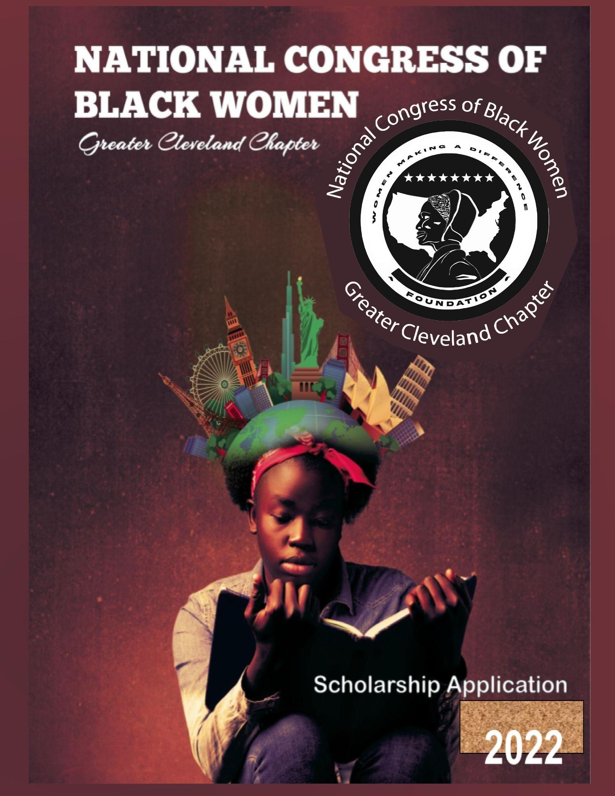 We Invite you to complete our fourth annual scholarship award application.
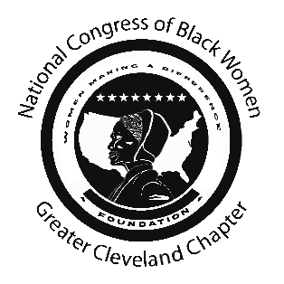

Two or more college scholarships in the amount of $500 will be awarded to a high-school senior(female) from the greater Cleveland area. Applications can be obtained from your high school counselors, chapter member, or by emailing: NCBWCleveland@gmail.com. Late applications will not be reviewed. (Application Deadline: March 29, 2022).
Each applicant must meet the eligibility requirements.
PRIMARY ELIGIBILITY REQUIREMENTS

High School Seniors
- Students who will receive their high school diploma from a high school during or at the conclusion of the current academic year and are immediately continuing their education at the beginning of the next academic year
- Students who Have a minimum GPA of 2.5
- Students who can demonstrate community service and involvement
- Students who have applied to and/or been accepted into a college or university (If awarded, must provide proof of enrollment such as letter of intent)
As a part of the application you also must submit:
  - A 500-800 word essay detailing your professional and academic goals creativity, completeness, and/or service
  - A letter of recommendation from your school counselor, teacher, or principal
  - A Letter of Recommendation detailing community service.
(Letters must include the recommenders contact information)
**** Applications are scored, based on: 1) Completeness; 2) Originality/ Creativity; 3) Demonstration of Service; 3) Neatness ****
How to Apply
- Complete the official Scholarship Application form
(Applications must be signed by parent or guardian)
- Send the completed application, letters of recommendation, and essay together to:
US Mail: 12680 Rockside Road Garfield Hts., Ohio 44125
Attn: NCBW Greater Cleveland Chapter, Women making A Difference Foundation
(Must be post marked by March 29, 2022)
EMAIL: NCBWCleveland@gmail.com
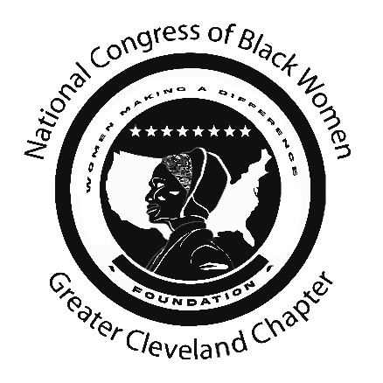

Name: ____________________________________________________________________________
First MI Last
Address: __________________________________________________________________________
Number and Street City State Zip Code

_________________________________________________(____)____________________________
E-mail Address Telephone

High School: ____________________________________________GPA: _______________________
College to attend in Fall 2022: _________________________________________________________
Applicant Signature: _____________________________________Date: _______________________
Parent/ Guardian Signature: ______________________________ Date: _______________________

School Activities: ___________________________________________________________________
__________________________________________________________________________________
__________________________________________________________________________________
__________________________________________________________________________________ __________________________________________________________________________________
__________________________________________________________________________________

Community Service Activities: ________________________________________________________
__________________________________________________________________________________
__________________________________________________________________________________
__________________________________________________________________________________
__________________________________________________________________________________

Honors/Awards Received: ___________________________________________________________
__________________________________________________________________________________ __________________________________________________________________________________ __________________________________________________________________________________
__________________________________________________________________________________
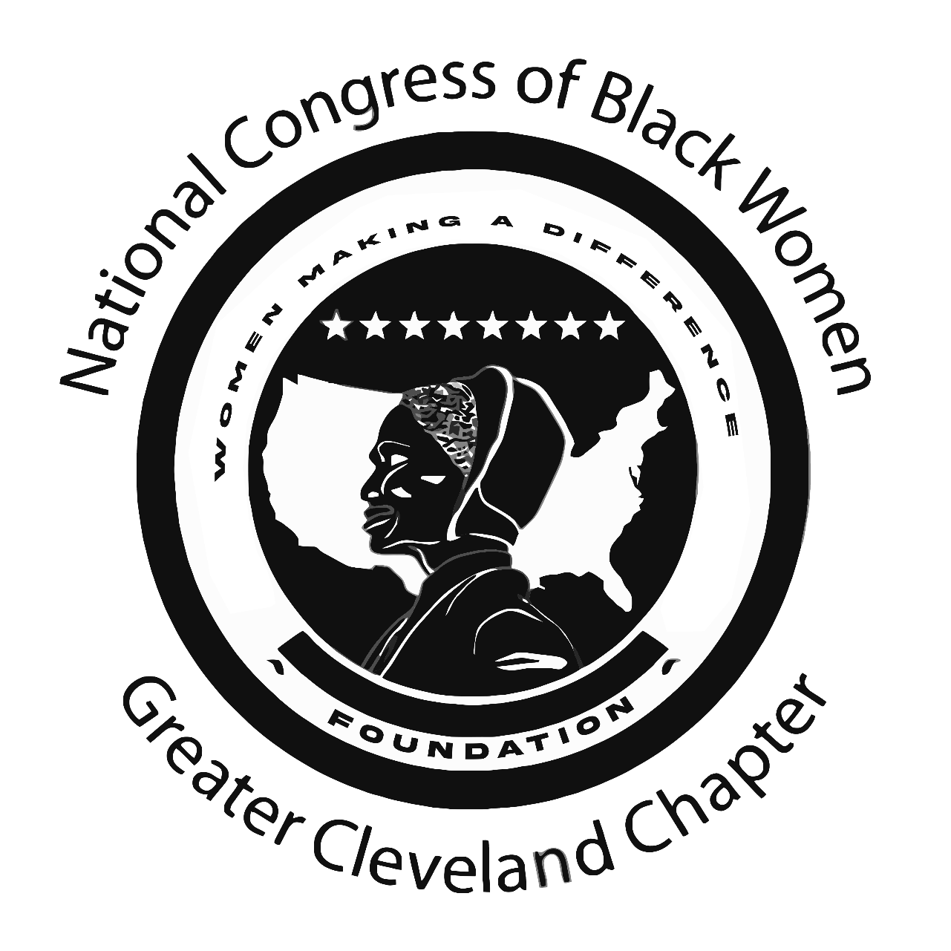

The National Congress of Black Women (NCBW) is a tax exempt 501 (c) (3) organization, founded in 1984 by political and social activist pioneers Shirley Chisholm (1st Black woman to make a serious bid for U.S. President) and Dr. C. Delores Tucker (1st Black woman elected as Secretary of State). Other notable NCBW founders include Dr. Dorothy Height and Coretta Scott King. The NCBW Greater Cleveland Chapter, Women Making A difference Foundation, was established September 18, 2016. Our mission is to advocate and empower the Black woman and her family in Greater Cleveland through social and political development, civic education, community engagement, and rebuilding socioeconomic opportunities. We envision a community in which all black girls and women are nurtured, empowered, and dedicating their time, talents, and resources to ensure that they are a part of the conversation at the decision-making table to address issues that impact black women, their families, and communities.

